NETWORK PROJECT
STATIC ROUTING
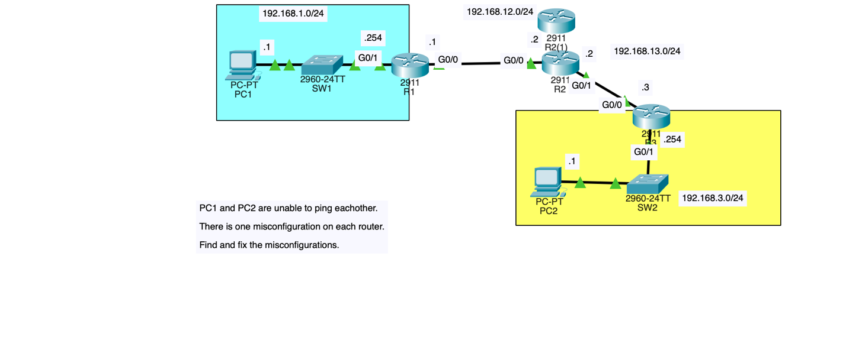

Project Goals
Configured a multi-router network using static routing to establish communication between two separate LANs. Identified and corrected router misconfigurations, configured static routes, and verified end-to-end connectivity by successfully pinging between PC1 and PC2.

Technologies Used
- Cisco Packet Tracer
- Cisco 2911 Routers
- Cisco 2960 Switches
- Static Routing
- IPv4 Addressing and Subnetting
- Router Interface Configuration
- CLI (Command-Line Interface)
- ICMP (Ping) Connectivity Testing

DYNAMIC ROUTING (OSPF)
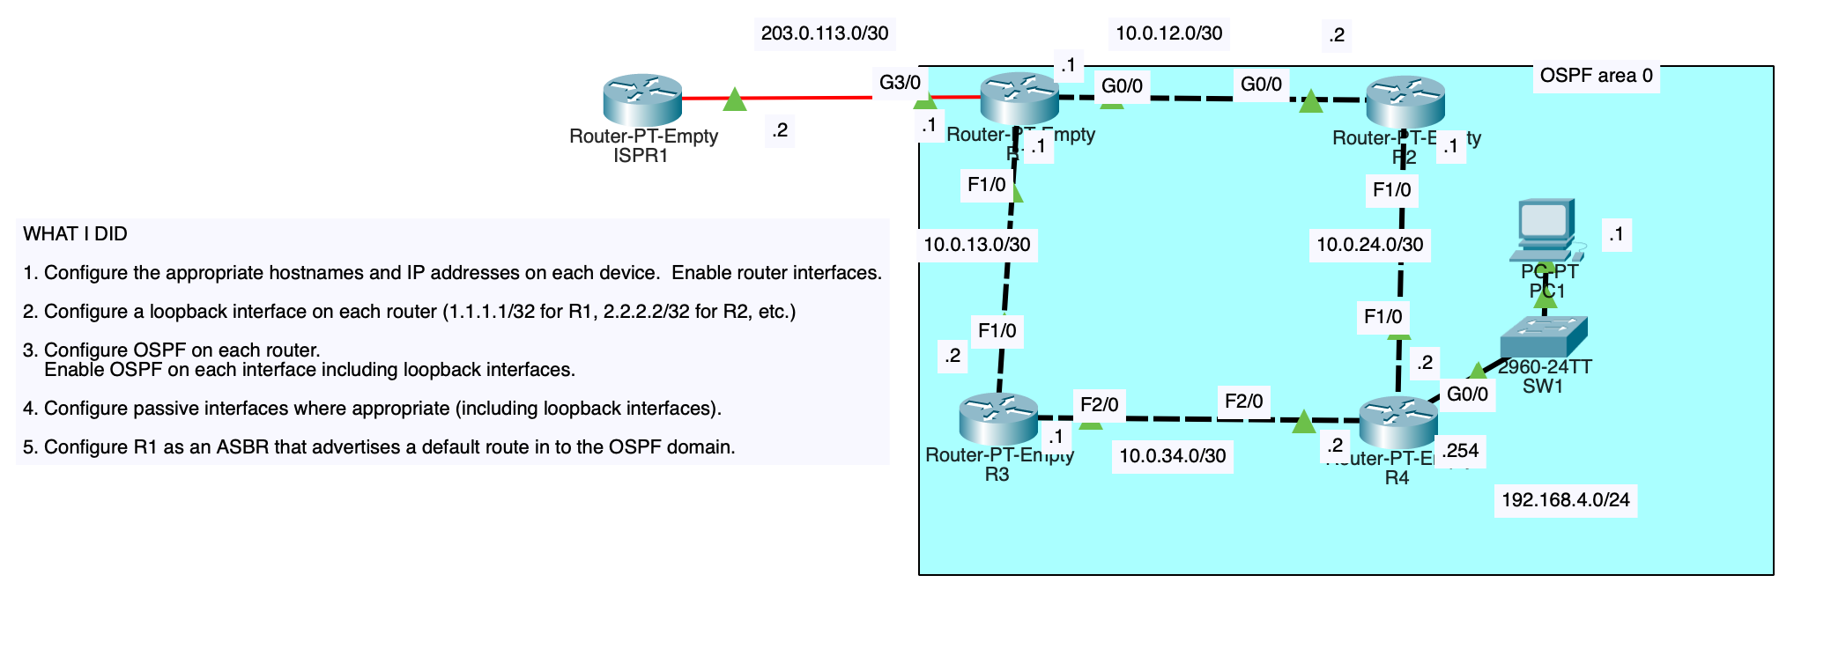

Project Goals
Designed and configured a multi-router network using OSPF (Open Shortest Path First) to enable dynamic routing and communication between multiple networks. Configured OSPF on all routers, established loopback interfaces, configured passive interfaces, and set up R1 as an Autonomous System Boundary Router (ASBR) to advertise a default route to the OSPF network.

Technologies Used
- Cisco Packet Tracer
- OSPF (Dynamic Routing Protocol)
- Cisco Routers and Switches
- IPv4 Addressing and Subnetting
- Loopback Interface Configuration
- OSPF Area 0
- Passive Interface Configuration
- Default Route Propagation
- ASBR (Autonomous System Boundary Router)
- CLI (Command-Line Interface)
- ICMP (Ping) Connectivity Testing

SPANNING TREE PROTOCOL
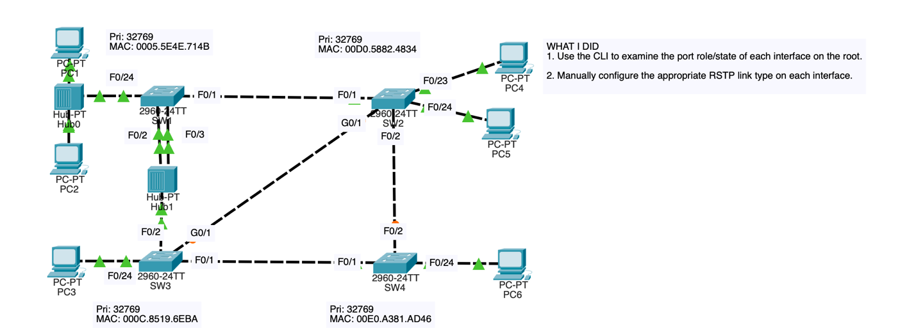

Project Goals
Configured and analyzed a multi-switch network using Spanning Tree Protocol (STP) to prevent Layer 2 switching loops. Identified the root bridge, examined switch port roles (root, designated, and non-designated), and observed how STP blocks redundant links to maintain a loop-free network while providing redundancy.

Technologies Used
- Cisco Packet Tracer
- Cisco Catalyst 2960 Switches
- Spanning Tree Protocol (STP)
- Root Bridge Election
- Root, Designated, and Non-Designated Port Roles
- Bridge ID (BID) and MAC Address Analysis
- Port Priority Configuration
- Redundant Link Management
- Layer 2 Switching

